**XposedModuleApp Manual**

# Pre installation requirements

* 1. Operating Environment - The XposedModuleApp system supports smartphones with Android 4.0 (there is a problem to install XposedBridge on Android 5.0 and above).
  2. The device needs to be rooted - giving us the ability to modify the core of the OS and perform operations that require root permissions.
  3. The device has to have "Xposed Installer" installed - It’s easy to install and configure from the android play store.
  4. The XposedModuleApp app needs to be installed- After installing, follow "Section 2" to activate the XposedModuleApp.

# Running the XposedModuleApp module on android devices

* 1. Make sure you meet the all the pre requirements at Section 1.
  2. Open the "Xposed Installer".

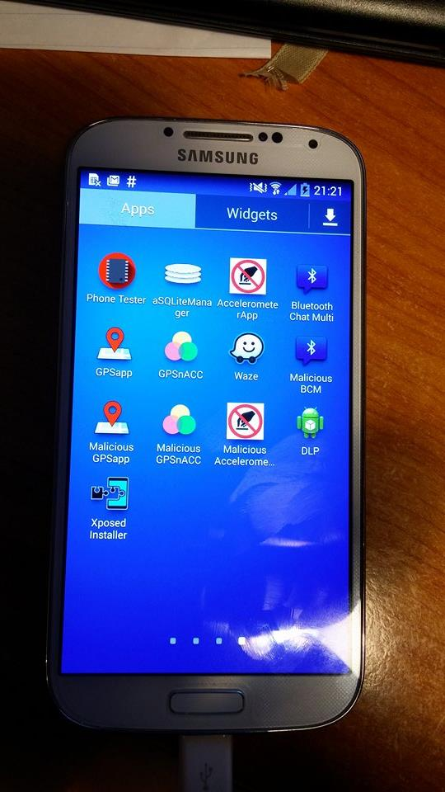

* 1. Click on "Modules".

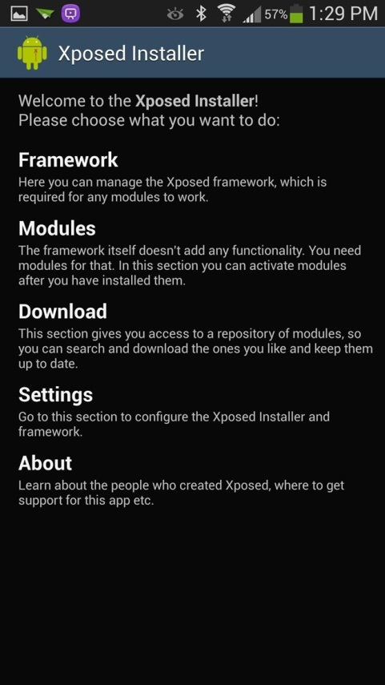

* 1. Check the XposedModuleApp model.
  2. Restart your device.

After the restart your android device the XposedModuleApp will be running on the device from boot startup.

# 

# Selecting Apps to sample

* 1. Press on Add new Sample
  2. Check Sample info that you want to sample and which App to sample and press Add.

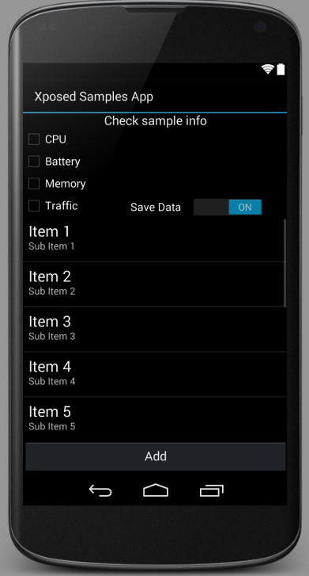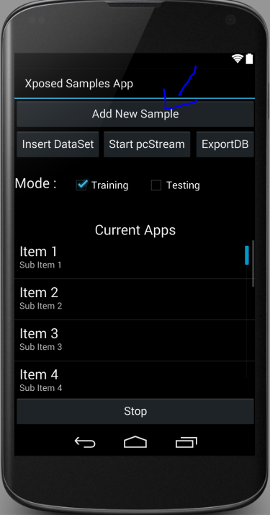

* 1. The app will appear on Current Apps and will start sample when App start.

# Removing Apps from sample

* 1. Press on App from the Current App List.
  2. Press the stop button.
  3. The App will stop sample and save the pcStream in XML file.